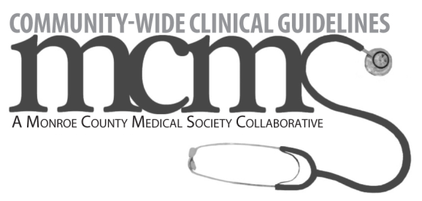
Pediatric Asthma Management Guideline Implementation
Physician Participation Attendance Form
For MOC eligibility, attendees’ names need to be listed on the Practice Project Update. List participating physicians in attendance for the team meeting.
During the practice project updates, refer to the list of questions to be used as a guide for discussion.* MCMS does not require physicians to document and submit written responses.
Date of team meeting: _____________________
Name | Practice Name

Sample team meeting agenda talking points
- Review data from previous data cycle.
- Discuss interventions implemented and the impact of those interventions (increase, decrease, no change).
  - How did the intervention impact missed opportunities?
  - How did the intervention impact the length of time for patients to wait for an available appointment?
  - How did the intervention impact length of patient visit?
  - How did the intervention impact staff satisfaction with workload?
  - How did the intervention impact other aspects of workflow?
- What impact has participation in this project had on clinical and operational work overall? (much easier, somewhat easier, same, somewhat more difficult, much more difficult)
- Were office systems disrupted due to intervention implementation?
  - If yes, how will you adapt the process?
- Discussion of interventions for next data cycle
  - What should we do?
  - What do we anticipate to see as a result?

